**Indoor Maps for Atkins Library – Documentation:**

Indoor Maps – Maps similar to google maps which we use in our routine, you get to experience live tracking of location, search for a particular destination and get turn by turn navigation to the same. How to achieve this inside the buildings?

1. Use the already developed software tools to build Indoor Maps by paying them (monthly/ annually) based on our requirements and the pricing plan which we choose. They provide all the functionality like placing the marker for a location, drawing the directions and navigations between two locations, elevators, multiple floor accessible path, disability accessible path, the path is one way/ two way.

Example: Mapwize, Indoor Atlas.

1. Develop the application from scratch.

Example: **Mapbox** (widely used), **Leaflet.js**

Type 1:

Implemented the Indoor mapping functionality as a sample using one of the software tools called **Mapwize**. The demo URL is here

<https://maps.mapwize.io/#/v/sample_map/1?k=a901e8790b5f5f12&z=18>. The similar one has also been implemented using **Indoor Atlas**.

Advantages:

Easy to develop indoor mapping on top of these software tools,

Easy to maintain.

Disadvantages:

Pricing,

Minimal customization or may have to pay more for more customization.

Less flexible

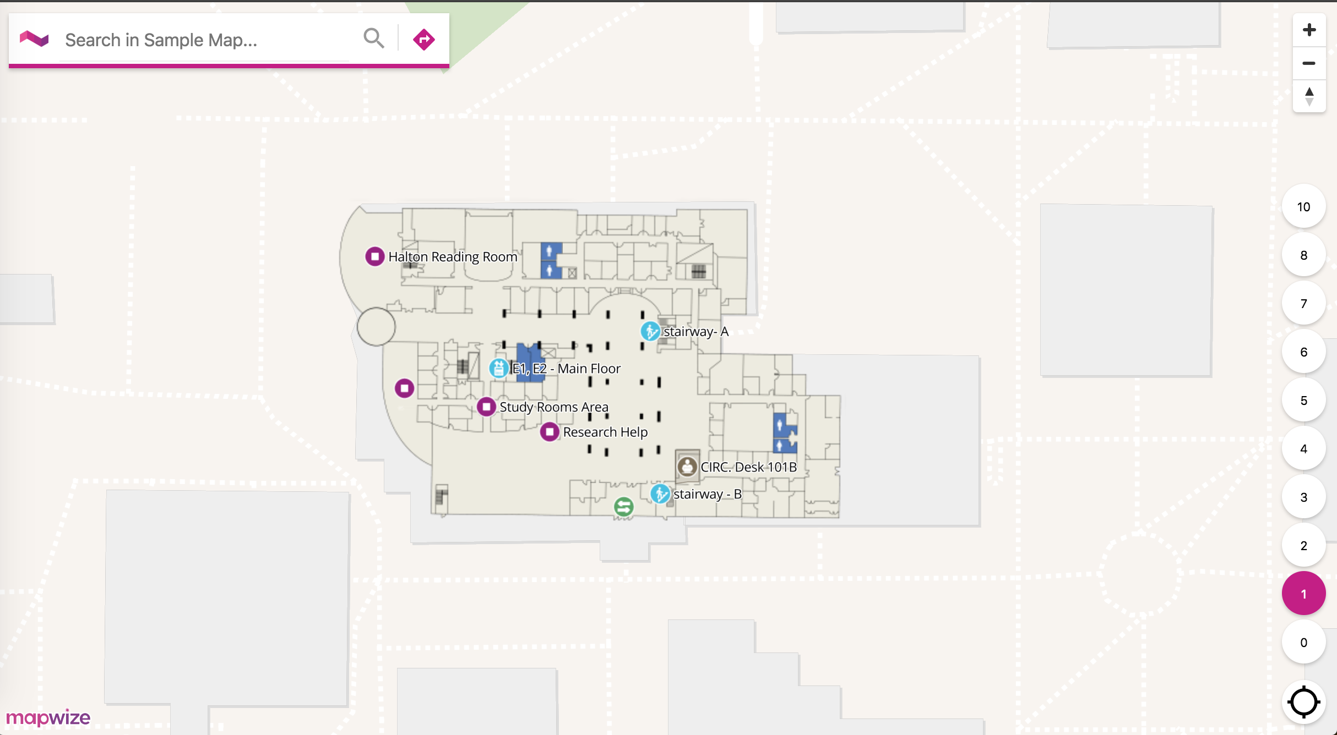

<https://maps.mapwize.io/#/v/sample_map/1?k=a901e8790b5f5f12&z=18>

Type 2:

Challenges to be faced to implement from scratch –

Indoor Mapping functionality requires mapping the indoor location (study rooms, viz labs) to actual geographic location using latitude and longitude which is called Geographic Information System. We can implement this in 2 ways

<https://www.mapbox.com/help/indoor-floorplans/>

1. Give the floor plan blue print/ SVG Image some geographic reference in order to work in a mapping application. (Georeferencing the Image)

**Georeferencing** is the process of assigning geographic coordinates to a raster image in order to define its location in the world based on a map coordinate system.

1. Draw the floor map in online editor <http://geojson.io/#map=2/20.0/0.0> and use it as GeoJSON in Mapbox.

GeoJSON: is an open standard format designed for representing simple geographical features, along with their non-spatial attributes. It is based on JSON (source - <https://en.wikipedia.org/wiki/GeoJSON> ).

We can draw lines (paths), polygons (location Eg: office room) and others.

Standard format for GeoJSON:

{

type: "FeatureCollection",

features: [

{

type: "Feature",

geometry: ...,

properties: {

...

level: 1

....

}

},

{

type: "Feature",

geometry: ...,

properties: {

...

level: [2, 3]

....

}

}

]

}

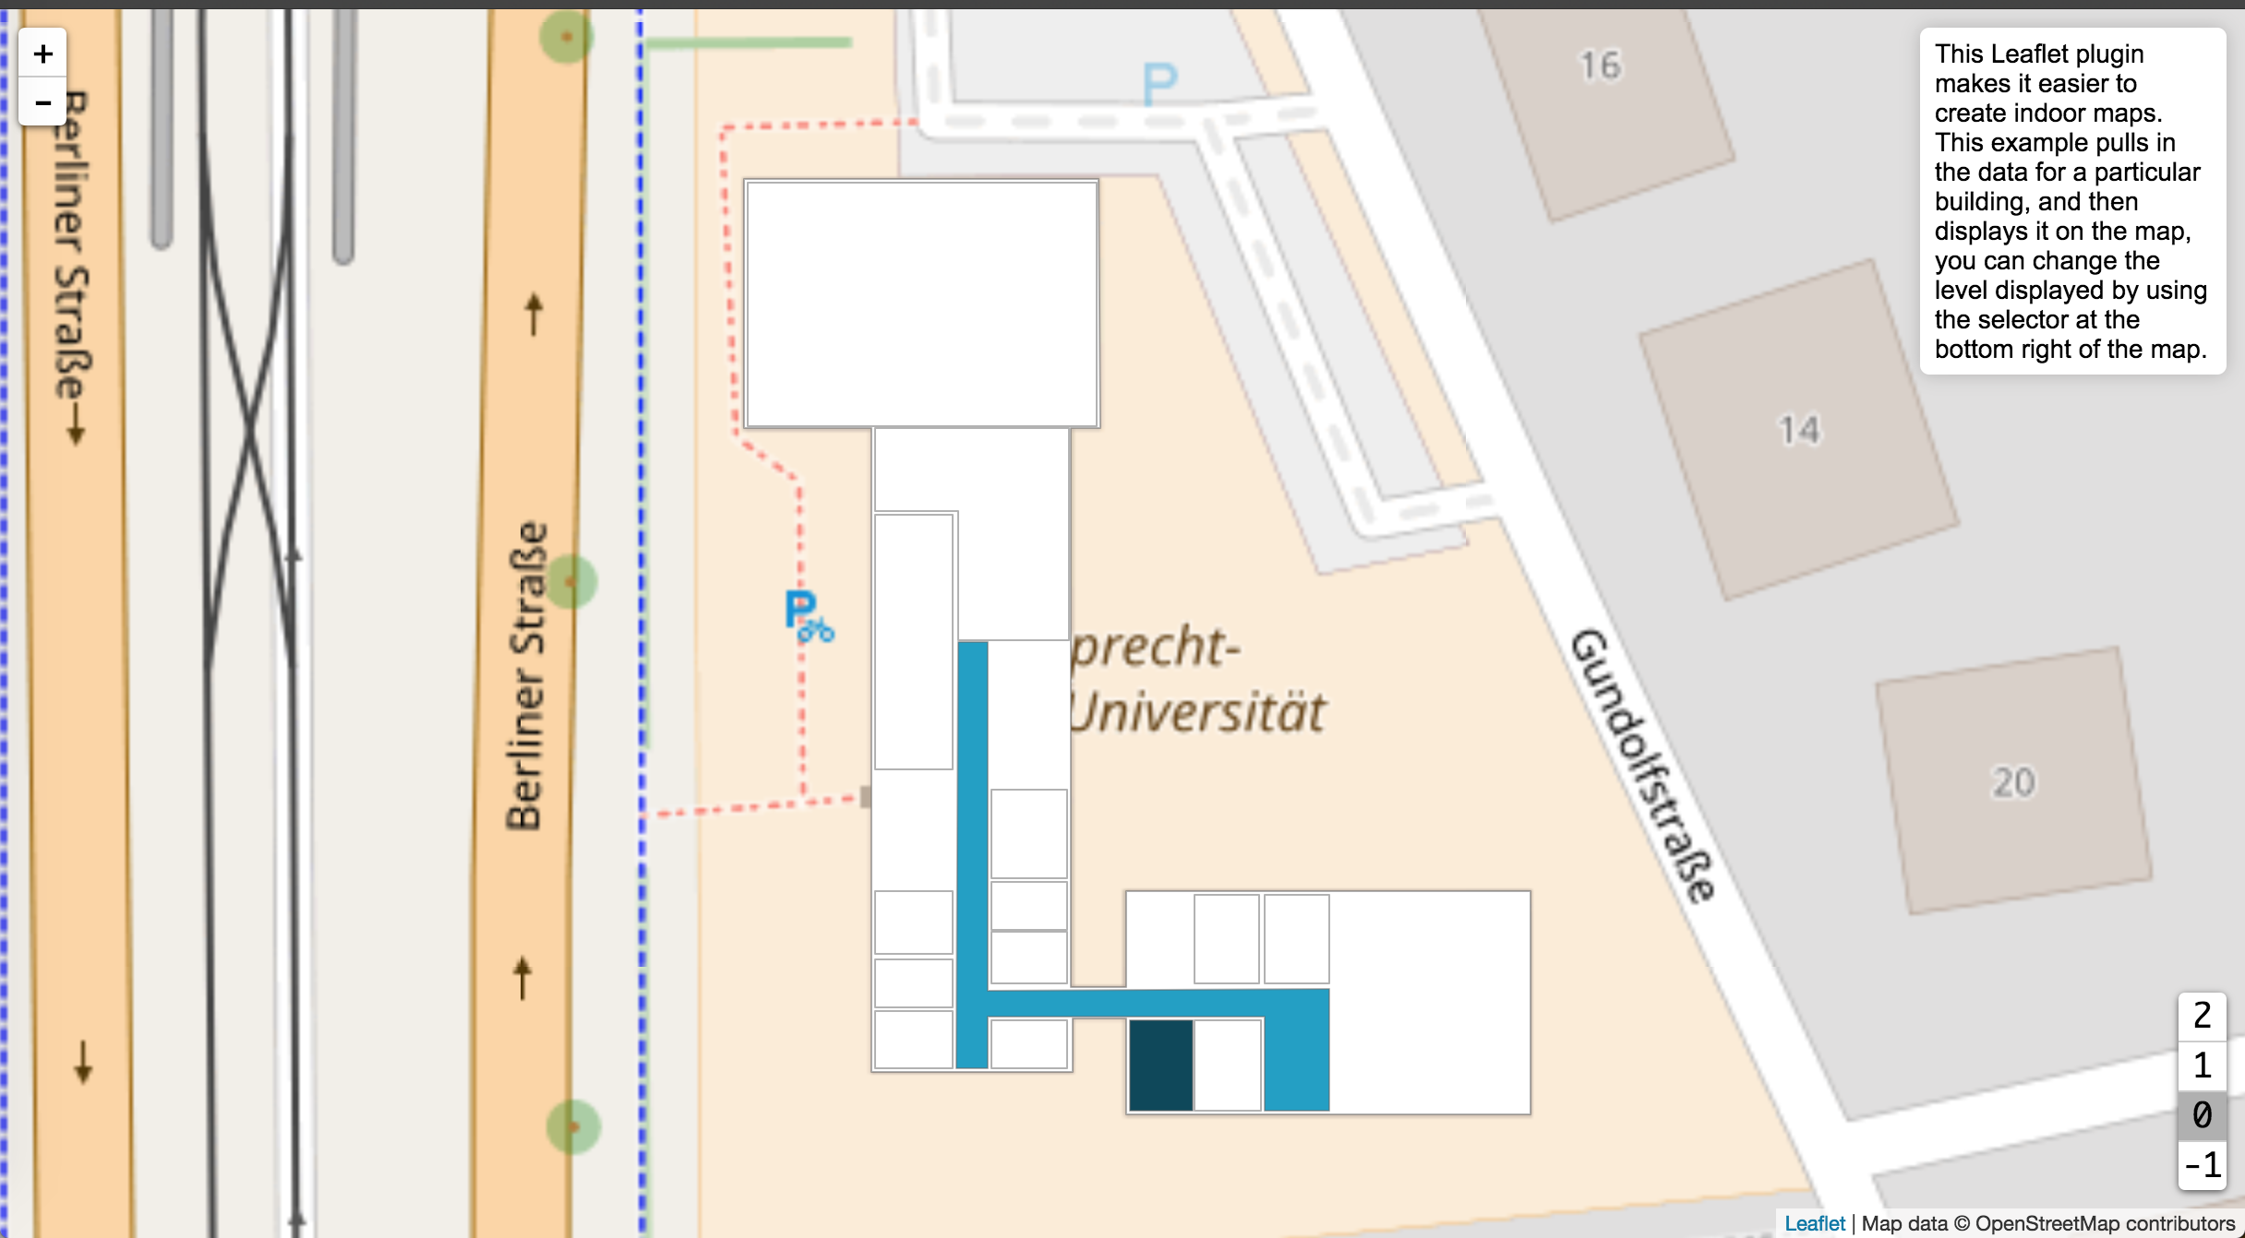

<https://www.cbaines.net/projects/osm/leaflet-indoor/examples/>

Advantages:

No monthly/ annual pricing,

More flexibility.

Disadvantages:

More resource, more time, more complex compared to previous one.